| Program Name: | 05 |
| --- | --- |
| Roll No: | 1510 |
| Title of Program: | Linear Search & Binary Search |
| Objective: | To implement Linear and Binary Search |

**CODE of Linear Search :**

/* Name: Advait Dhakad

Roll No: 1510

Unit 1: Sorting & Searching

Program: Linear Search */

#include<iostream>

using namespace std;

int main(){

int arr[10],n,i,k;

cout << "\t *** LINEAR SEARCH ****** \n";

cout << "Enter the size of array: ";

cin >> n;

for(i=0;i<n;i++){

cout << "Enter the element at " << i << ":";

cin >> arr[i];

}

cout << "Original Array :";

for(i=0; i<n; i++){

cout << arr[i] << " ";

}

// BINARY SEARCH

cout << "\nEnter the number you want to search: ";

cin >> k;

int flg = 0;

for (i=0; i<n; i++){

if (arr[i] == k){

cout << "ELEMENT FOUND at index: " << i;

flg = 1;

break;

}}

if(flg == 0){

cout << "Element not found";

}

}

**OUTPUT of Linear Search:**

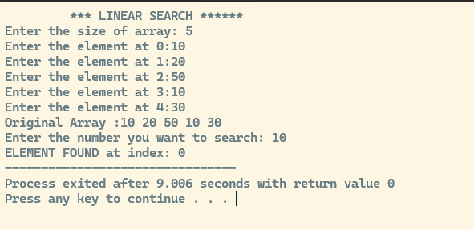

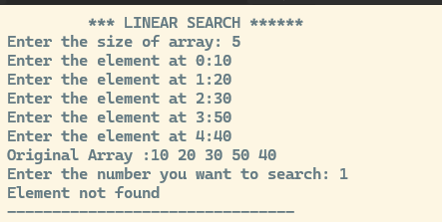

**CODE of Binary Search:**

/* Name: Advait Dhakad

Roll No: 1510

Unit 1: Sorting & Searching

Program: Binary Search */

#include<iostream>

using namespace std;

int main(){

int arr[10],n,i,k;

int first, mid, last;

cout << "\t ***** BINARY SEARCH ****** \n";

cout << "Enter the size of array: ";

cin >> n;

for(i=0;i<n;i++){

cout << "Enter the element at " << i << ":";

cin >> arr[i];

}

cout << "Original Array :";

for(i=0; i<n; i++){

cout << arr[i] << " ";

}

// Binary Search

cout << "\nEnter the element you want to seach: ";

cin >> k;

int flag = 0;

first = 0;

last = n-1;

while (first <= last){

mid = (first+last)/2;

if(arr[mid] == k){

cout << "\nThe Element is Found at " << mid << " index \n";

flag = 1;

break;

}

else if(arr[mid] > k ){

last = mid -1;

}

else {

first = mid +1;

}

}

if (flag == 0){

cout << "\nElement not Found in the Array";

}

}

**OUTPUT of Binary Search:**

